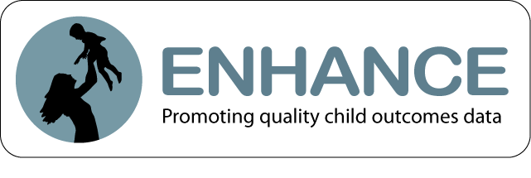
Project Objectives:
- Conduct a program of research to examine the validity of ratings generated by the Child Outcomes Summary (COS) process and identify conditions that reduce and support validity
- Revise the COS form and supporting materials based on study findings
- Identify a series of validity analyses that can feasibly be conducted in states to allow each state to examine the validity of its own COS data on an ongoing basis

Status of Studies to Test Validity Claims:
Study | Focus | Data Source | Status/Timing
1. Comparison with Child Assessments Study | Investigate relationships between COSF ratings and the Battelle Developmental Inventory (BDI-2) and the Vineland Scales of Adaptive Behavior (Vineland-II) in children at program entry and again at program exit | 36 local programs | Enrolling now, longitudinal until children exit program/district.  Currently have completed:  - 154 entry assessments: 96 EI, 58 ECSE  - 63 exit assessments: 38 EI, 25 ECSE  Projection: 165 entry,70 -100 exits  (stop assessing January 2014)
2. Team Decision-Making Study | Video team meetings where ratings are determined to examine if rating is consistent with information discussed, how ratings are applied, and impact of team members | 36 local programs | Collecting data, coding videos.  Currently have:  - 131 videos received  79 EI, 52 ECSE; 86 entry, 45 exits  Projection: acquire 160-180 videos,  code 85 -100 videos
3. Provider Survey | Online survey of providers involved in COSF ratings about their experiences | 36 local programs | Survey completed with 856 providers in Spring 2012. Currently analyzing findings.
4. Extant State Data Study | Analyze statewide data patterns and relationships of COSF ratings with other variables to investigate consistency of validity claims across states. | Extant data from interested states | Refined procedures with initial states. Gathering additional data that were recently submitted.  Currently, data received from:  - 9 Part B Preschool states  - 6 Part C states
*EI = Early intervention, ECSE = Early Childhood Special Education

Participating States:
Our sincere appreciation to the following 8 states for their participation and to the state staff for connecting us with the 36 local programs
Part C: Illinois, Maine, Minnesota, New Mexico, North Carolina, Texas, Virginia
Part B Preschool: Illinois, Maine, Minnesota, New Mexico, South Carolina, Texas

We also appreciate involvement of states in the state data study, although these states will not be publicly identified.

Findings:
Data from studies are being collected now. Some early analyses are underway, including a presentation on descriptive findings from the provider survey at a recent conference. In participating local programs, there is considerable variation in the amount and type of COSF training providers received and the approach for implementing the COSF process.
