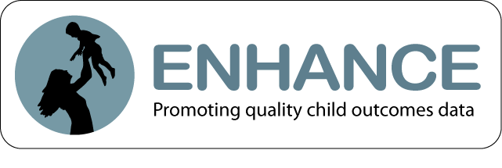
Team Decision-Making Study
Content Coded in Videos

Meeting and Participant Information: Description about type of meeting where COS was decided, participants involved, and their backgrounds.
Type of meeting where ratings were decided (e.g, embedded in IFSP/IEP, COS-only meeting). | Number and roles of individuals who contributed information to the rating and/or participated in the rating decision. | Years of experiences providing services to children with disabilities and to children without disabilities.
Entry or exit meeting. | Number of parents/guardians present in meeting. | Hours of COS training received by providers.
Length of meeting and length of time spent discussing each outcome. | Number of COS meetings the providers have participated in. | Providers self-reported knowledge related to the COS process.

Informing and Engaging Family Members: Information explained to families and their participation in COS process.
Providers explain to families why outcomes data are collected. | Providers describe to families the meaning of the three child outcomes. | Families share information about their child’s functioning without prompting from providers.
Providers review with families the skills expected at the child’s age and the sequence in which those skills develop. | Providers invite family members to share observations and input during the meeting.

Team Process and Consensus: General interaction approach and dialogue between members at the COS meeting.
Extent of relevant contributions and dialogue between team members.  Consensus agreement on the COS ratings and the rationale for the ratings. | Amount of family input described or shared (minimal, considerable).  Overall rating of team process. | Format of input received from family members (e.g. professional shared based on separate discussions, family participation in team meeting).

COS-Specific Process: Team incorporates best practices and understanding of COS-related content in meeting.
Team discussed the child’s functional use of skills. | Team described skills the child has not yet mastered. | Team considered more than one rating.
Team considered the child’s functioning across multiple settings and situations. | Team correctly age-anchored specific skills. | Team explicitly states a rationale for rating for reach outcome.
Team discussed skills relevant to each of the three outcomes. | Team referenced one or more specific assessment tools. | Team showed no explicit intent to alter ratings.
Team considered the full breadth of skills associated with the outcome. | Team referenced or used the decision tree in the process of deciding the rating. | Overall rating of COS-specific process.
Team considered the child’s skills with the appropriate depth. | No misunderstanding of rating criteria was evident.

Ratings: Team ratings are consistent with specific rating or range of ratings determined by coding after reviewing the video and COS form.

Documentation: Review of COS form to consider if paperwork is complete and provides evidence that justifies the rating.

COS form is complete, with evidence documented for each outcome. | COS evidence listed is identified with the appropriate outcome area. | Evidence documented is consistent with and/or sufficient to justify the rating.

